A

Tribhuvan University Affiliated College

**Samriddhi College**



**6th Semester Project Report**

**On**

(In partial fulfillment of the requirement for the Bachelor degree in Computer Science and Information Technology)

**Submitted to:**

Department of Computer Science and Information Technology, Samriddhi College Lokanthali, Bhaktapur

**Submitted by:**

Aayush Dhakal (161)

Rupesh Bhasima (16165)

Wilson Shrestha (16180)

**ACKNOWLEDGEMENT**

I would like to express my special thanks of gratitude to my project guide << Name of guide>> as well as our principal Sandeep Shrestha who gave me the golden opportunity to do this wonderful project on the topic << project title >>, which also helped me in doing a lot of research and we came to know about so many new things we are really thankful to them.

We would like to thank Mr. Sudip Raj Khadka, our Project Supervisor, who with his continuous support and effort, made the research upon the problem of task distribution. Similarly, we cannot stay without expressing our gratitude to Mr. Sandeep Shrestha, the Principal of Samriddhi College, for providing us an opportunity to perform our research activities and come up with a working solution that would be beneficial for a large mass of people.We are thankful and fortunate enough to get constant support from our colleagues and teaching staff of B.Sc.CSIT department, which helped us, complete our project. We would also like to extend our regards to all the non-teaching staff of B.Sc.CSIT department for their timely support. Lastly, we are thankful to all the helping hands who always welcomed us with their warm support at the time when we needed them. Also, we would like to apologize for the mistakes that may have been committed in this project proposal.

**TABLE OF CONTENTS**

|  |  |  |
| --- | --- | --- |
|  | **TITLE** |  |
|  | **ABSTRACT** | **iii** |
|  | **LIST OF TABLES** | **v** |
|  | **LIST OF FIGURES** | **vi** |
|  | **LIST OF SYMBOLS AND ABBREVIATIONS** | **vii** |
| **1.0** | **INTRODUCTION** | **1** |
|  | 1.1 Sub section | 1 |
|  | 1.2 Sub section | 1 |
| **2.0** | **LITERATURE REVIEW** | **2** |
|  | 2.1 Sub section | 2 |
|  | 2.2 Sub section | 2 |
| **3.0** | **METHODOLOGY** | **3** |
|  | 3.1 Sub section | 3 |
|  | 3.2 Sub section | 3 |
| **4.0** | **EXPERIMENTATION** | **4** |
|  | 4.1 Sub section | 4 |
|  | 4.2 Sub section | 4 |
| **5.0** | **RESULT AND DISCUSSION** | **5** |
|  | 5.1 Sub section | 5 |
|  | 5.2 Sub section | 5 |
| **6.0** | **CONCLUSION** | **6** |
| **7.0** | **FUTURE SCOPE** | **7** |
|  | **REFERENCES** | **8** |

**ABSTRACT**

Abstract should be one page synopsis of the project report typed double line spacing, Font Style Times New Roman and Font Size 12.

vi

**LIST OF TABLES**

|  |  |  |
| --- | --- | --- |
| **Table No.** | **Title** | **Page No.** |
| Table 1.1 | Name of the table | 1 |
| Table 2.1 | Name of the table | 2 |
| Table 3.1 | Name of the table | 3 |

vi

**LIST OF FIGURES**

|  |  |  |
| --- | --- | --- |
| **Figure No.** | **Title** | **Page No**. |
| Figure 1.1 | Name of the figure | 1 |
| Figure 1.1 | Name of the figure | 2 |
| Figure 1.1 | Name of the figure | 3 |

viii

**LIST OF SYMBOLS AND ABBREVIATIONS**

|  |  |
| --- | --- |
| **Symbol** | **Explanation** |
| $ | Dollar |
|  |  |

ix

1. **INTRODUCTION**

This chapter should contain brief background information about the project, the methodology implemented for problem-solving, and the outlines of the results and future scope of the project. It rarely contains drawings and graphical illustrations.

1. **LITERATURE REVIEW**

It evaluates the current work with the previous one. It depicts the current implementations that overcome the previous problems and limitations of the project, and draws the attention and focus on the foreknowledge work that would be conducted based on the ongoing work at present. It must be clear and simple to understand.

1. **METHODOLOGY**

Essentially, a methodology is a collection of methods, practices, processes, techniques, procedures, and rules

Explain your methodological approach.

Describe your methods of data collection and/or selection.

Describe your methods of analysis.

Evaluate and justify your methodological choices.

Table 3.1 : Title of the table

|  |  |  |
| --- | --- | --- |
| **Heading** | **Heading** | **Heading** |
| Data | Data | Data |
| Data | Data | Data |

Figure 3.1 : Title of the image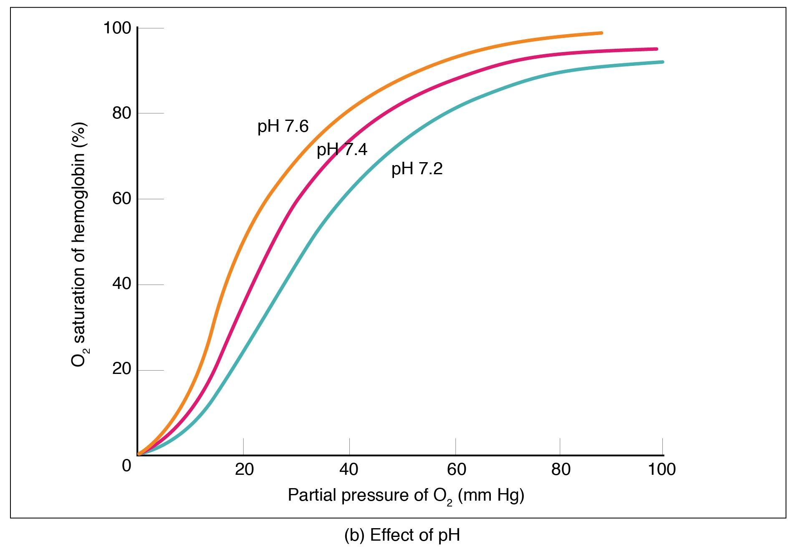

1. **EXPERIMENTATION**

Write the experimental procedure like a step-by-step recipe for your science experiment. A good procedure is so detailed and complete that it lets someone else duplicate your experiment exactly!

1. **RESULT AND DISCUSSION**

This section should be written in the present tense. The Discussion section needs to follow from your results and relate back to your literature review.

Interpret and explain your results.

Answer your research question.

Justify your approach.

Critically evaluate your study.

1. **CONCLUSION**

The conclusion and recommendations part summarizes the whole report by highlighting all the chapters and their significance and the importance of the project and the achievements.

1. **FUTURE SCOPE**

Scope for future development if any

**REFERENCES**

1. Shin, K.G. and Mckay, N.D. (1984) ‘Open Loop Minimum Time Control of Mechanical Manipulations and its Applications’, Proc.Amer.Contr.Conf., San Diego, CA, pp. 1231-1236.